Long Division of Polynomials  Handout-Answers | Name:  Date:

Objective: Long Division of Polynomials

Segment 1: Using the Long Division Algorithm to Divide Integers

Example-1 Divide 6586 by 28. Write the answer in 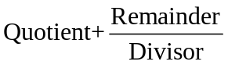form.

Segment 2: We can divide polynomials by polynomials by factoring and dividing out common factors. For those polynomials, however, that do not factor easily, we can use a more general procedure that follows a “long division algorithm” similar to the algorithm used for dividing integers.

Steps that can be used when dividing polynomials

- Write the dividend and divisor in descending powers of the variable.

- Insert placeholders with zero coefficients for missing powers of the variable.

- Divide the first term in the dividend by the first term in the divisor. The result will be the first term in the quotient.

- Multiply every term in the divisor by the first term in the quotient. Write the resulting product beneath the dividend with similar terms under each other.

- Subtract the product from the dividend.

- Bring down the next term in the original dividend and write it next to the remainder to form a new dividend.

- Use the new expression as the dividend and repeat this process until the remainder can no longer be divided. That is, the degree of the remainder is less than that of the divisor.

Example-2 Divide 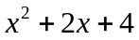by 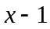 Answer: 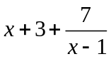

Example -3 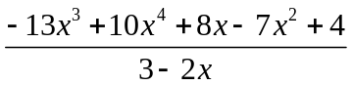 Answer: 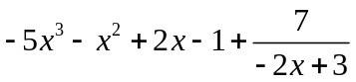

Example -4 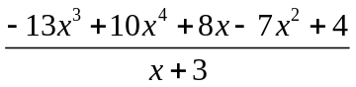 Answer: 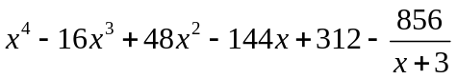

Practice- 1 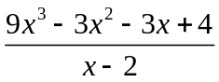 Answer: 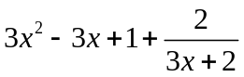

Practice-2 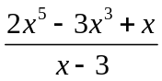 Answer: 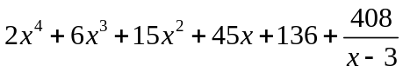

Practice 3 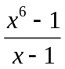 Answer: 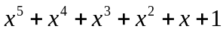

Practice 4 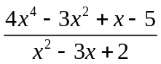 Answer: 